

Cloud Solution

for

Mercado Municipal de São Paulo

By Natasha de Lima

Table of Contents

Page 1 Milestone #1 - Cloud Principles and Design
Business Description and Research
Deployment Model
Service Model
Infrastructure Diagram
Page 4 Milestone #2 - Cloud Networking & Storage
Additional Business Research
Procedures when ISP goes down
Virtual Private Network
Kinds of Files Stored
How will Business Connect?
Domain Name System
Storage Providers
Content Delivery Network
Page 5 Milestone #3 - Assessing Cloud Needs
Research
Framework Diagram
Baseline
Feasibility
Gap Analysis
Gap Analysis Diagram
Page 6 Milestone #4 - Engaging Cloud Vendors
Capital and Operating Expenditures
Potential Cloud Vendors
Variable and Fixed Costs
Licensing Model
Evaluation of Cloud Vendors
Service Level Agreement
Migration Principles

Page 7 Milestone #5 - Management and Technical Operations
Aspects of Operating
Development & Operations
Financial Planning
Page 8 Milestone #6 - Compliance and Security
Data Sovereignty
Regulatory Concerns
Industry-Based Requirements
International Standards
Certifications
Security Concerns, Measures, and Concepts

Page 9 Milestone #7 - Governance and Risk
Risk Assessment
Risk Response
Documentation
Vendor Lock-In
Policies and Procedures

Milestone #1 - Cloud Principles and Design

Business Research

Business Name | Mercado Municipal de São Paulo
Number of Employees | The market has many vendors and workers. It is estimated that more than 200 people work in different stalls and restaurants inside the market.
Location(s) | São Paulo, Brazil. The market is located in the central area of the city near Rua 25 de Março.
How long has the company  been in business | The Mercado Municipal opened in 1933, so it has been operating for more than 90 years.
Purpose of the Business | The purpose of the business is to sell fresh food products such as fruits, vegetables, meat, seafood, spices, and traditional sandwiches. It also serves as a tourist attraction and a place where people can eat and shop for specialty foods.
Existing Technologies | Many vendors use POS systems for payments, card machines, computers for accounting, WiFi networks, and social media to promote their products. Some businesses may also use delivery apps and inventory systems.
Other Notes | The market receives a large number of visitors every day, including tourists and local residents. Because of the high volume of sales and transactions, cloud technology could help improve data storage, inventory management, and backup systems.

Deployment Model

A public cloud deployment model would be appropriate for this business. Public cloud providers such as AWS, Microsoft Azure, or Google Cloud can offer scalable resources without requiring the business to maintain physical servers. This model allows vendors to access systems through the internet while reducing hardware costs and improving reliability.

Service Model

The best service models for this business would include Software as a Service (SaaS) and Infrastructure as a Service (IaaS). SaaS could be used for inventory systems, accounting software, and customer management platforms. IaaS could provide virtual servers and storage to host applications and backup data securely in the cloud.

Cloud Design for your Business

The cloud solution will centralize business data such as sales records, inventory information, and customer transactions using cloud-based platforms. To ensure high availability, the system will use multiple cloud servers across different regions, allowing the system to remain accessible even if one server fails. Load balancing will distribute traffic efficiently, preventing system overload during peak business hours.
To support redundancy and disaster recovery, data will be automatically backed up in multiple locations within the cloud. In case of system failure, data can be quickly restored with minimal downtime. This design ensures that the business can continue operating smoothly, protects critical data, and reduces the risk of data loss or service interruption.

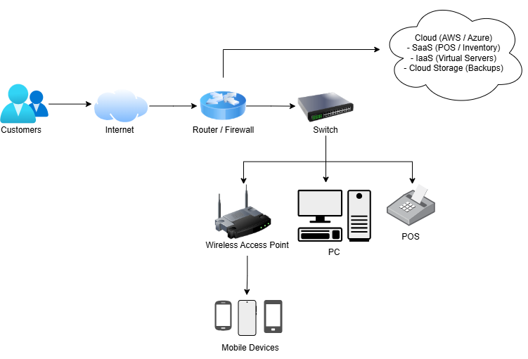
Infrastructure Diagram

Milestone #2 - Cloud Networking and Storage

Additional Business Research

Internet Service  Provider Name | The business uses different commercial Internet Service Providers (ISPs), including Claro, Vivo, and TIM, throughout the market. These providers are widely available in São Paulo and support the business operations
Data Connection Type | The business uses a fiber optic connection to provide high-speed and reliable internet access.
Download and Upload speeds | Estimated speeds range from 200 Mbps to 1 Gbps download and 100 Mbps to 500 Mbps upload depending on the provider.
More than one ISP? | The business uses multiple ISPs across different vendors within the market to ensure connectivity and reduce the risk of downtime.

Procedures when ISP goes down

If an ISP connection fails, operations can continue using alternative connections from other vendors within the market. Additionally, backup connections such as mobile data can be used to maintain critical services until the primary connection is restored.

Virtual Private Network

The business does not currently use a Virtual Private Network (VPN). However, a VPN could be implemented in the future to provide secure remote access and protect sensitive data during transmission.

Kinds of Files Stored

The business stores sales transactions, inventory data, financial records, supplier information, and marketing content such as images and promotional materials.

How will the Business Connect?

The business will connect to cloud services through a secure internet connection using routers, firewalls, and network switches. Devices such as POS systems and computers will access cloud applications and storage.
Mobile devices will connect to cloud services through wireless access points and the internet, allowing employees to access data and systems remotely.

Domain Name System

The Domain Name System (DNS) ensures that the business is able to communicate with cloud networking services by translating domain names into IP addresses. This allows business systems and devices to locate and connect to cloud services quickly and reliably over the internet.

Storage Providers

Cloud storage providers can be used to securely store business data, provide backups, and allow access from multiple locations. I recommend cloud-based storage providers such as Amazon S3, Microsoft Azure Storage, and Google Cloud Storage. These providers offer secure, scalable, and reliable storage solutions that allow the business to store large amounts of data, perform automatic backups, and access information from multiple locations.

Content Delivery Network

A Content Delivery Network (CDN) reduces delay (latency) by delivering content from servers that are geographically closer to users. This decreases the distance data must travel, resulting in faster load times and improved performance for applications and services. A Content Delivery Network (CDN) can be used to improve performance by delivering content quickly and reducing latency for users accessing services.

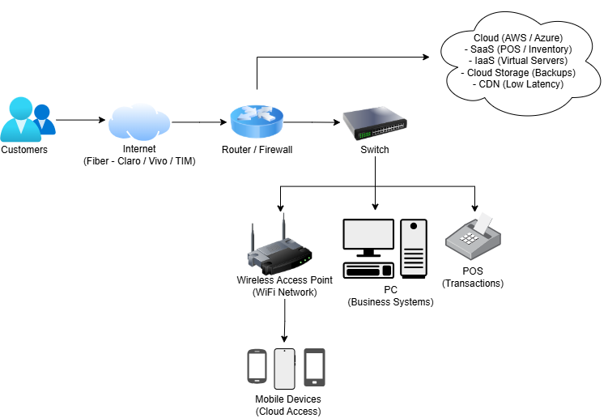
Updated Infrastructure Diagram

Milestone #3 – Assessing Cloud Needs

Research

Key Stakeholders | The key stakeholders include market management, vendors (business owners), employees, customers, and IT support staff.
Single Point of Contact for each department | Since the market has multiple vendors, each vendor owner can act as the point of contact for their business operations. Market management will act as the point of contact for overall coordination and infrastructure.
SPOC for the organization | The main SPOC for the organization will be the market manager or administrator, who is responsible for decision-making and communication regarding the cloud solution.

Business

The business wants to improve data organization, increase efficiency in transactions, ensure data security, enable remote access, and reduce the risk of data loss. The business needs a centralized system for managing sales and inventory, reliable data backups, improved communication systems, and scalable solutions to support growth.
Currently, the business relies on local systems and basic digital tools, which can lead to data loss and inefficiency. In the future, the business will require centralized cloud storage, scalable applications, secure data access, and improved system reliability.
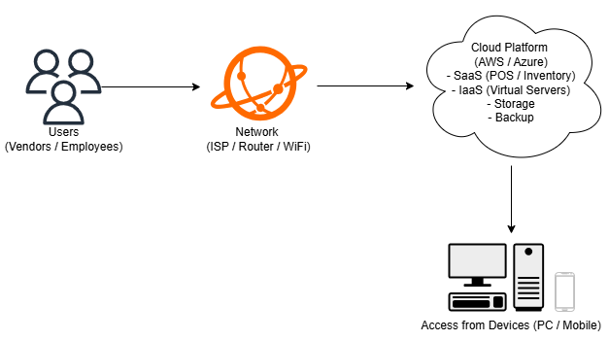
Framework Diagram

Baseline

The current environment performs basic operations such as sales and communication, but it lacks centralized data management and reliable backup systems. Performance depends heavily on local devices and internet availability. There are no formal benchmarks, but the system is limited in scalability, security, and efficiency.

Feasibility

The future requirements do require cloud solutions, as the business needs improved data management, scalability, and reliability.
The company has the basic capabilities to migrate to the cloud, including internet access, computers, and staff familiar with basic technology. Cloud services are user-friendly and do not require advanced technical knowledge.
Cloud computing replaced older technologies like punch cards and early transistor-based systems, which were limited in speed and storage. Modern cloud systems provide faster processing, better storage, and remote accessibility.
The business can offload data storage, backup systems, application hosting, and system management to the cloud, reducing the need for physical infrastructure.

Gap Analysis

There are several gaps between the current state of the business and the desired cloud-based system. Currently, the business relies on manual and disconnected processes, while the goal is to implement a centralized digital system that improves efficiency. Employees have limited knowledge of cloud tools, so training will be needed to ensure they can effectively use new technologies. Additionally, there are no defined governance policies, so the business will need to establish clear rules for data management, access control, and system usage. The current platform is based on local systems, but it needs to transition to a cloud-based infrastructure to improve scalability and reliability. In terms of security, the business currently has basic protection, but it requires secure cloud storage and regular backups to protect important data. Operationally, many tasks are still performed manually, and these should be automated using cloud-based tools to improve productivity.
- Business: Manual and disconnected processes → Centralized digital system
- People: Limited knowledge of cloud tools → Trained users
- Governance: No defined policies → Clear data management and access policies
- Platform: Local systems → Cloud-based infrastructure
- Security: Basic protection → Secure cloud storage and backups
- Operations: Manual tasks → Automated and efficient workflows

Gap Analysis Diagram

Category | Current  State | Goal | Action  Needed | Priority | Owner | Due  Date
Business | Manual Processes | Centralized System | Implement Cloud Tools | High | Manager | 3 months
People | Limited Training | Skilled Users | Provide Training | Medium | Admin | 2 months
Governance | No Formal Policies | Defined Policies and Procedures | Create Data Access and Usage Policies | Medium | Manager | 3 months
Platform | Local Systems | Cloud Platform | Migrate Data | High | IT | 4 months
Security | Basic Security | Secure Cloud | Add backups & Access Control | High | IT | 2 months
Operations | Manual Tasks | Automated Workflows | Use SaaS Tools | Medium | Staff | 3 months

Milestone #4 – Engaging Cloud Vendors

Capital and Operating Expenditures

Capital Expenditures
One example is purchasing new POS systems or computers for vendors inside the market. These are long-term investments that the business owns and uses over time. Another example is upgrading network infrastructure like routers and switches, which require upfront costs but support long-term operations.
Operating Expeditures
One example is paying for cloud services such as storage or virtual servers on a monthly basis. Another example is internet service costs, since the business depends on continuous connectivity to access cloud systems. These are ongoing costs that support daily operations.

Potential Cloud Vendors

Two cloud vendors that would be suitable for this business are Amazon Web Services (AWS) and Microsoft Azure.
AWS offers a wide range of services such as storage (S3), virtual machines (EC2), and backup solutions. It is known for its scalability and reliability.
Microsoft Azure provides similar services, including virtual machines, cloud storage, and strong integration with Microsoft tools like Office 365, which can be useful for business operations and management.

Variable and Fixed Costs

Variable Costs:
One example is cloud storage usage, since the cost depends on how much data the business stores. Another example is compute usage (virtual machines), where the cost increases or decreases based on usage.
Fixed Costs:
One example is a monthly subscription for software like accounting systems (SaaS). Another example is a fixed internet plan that the business pays every month regardless of usage.

Licensing Model

A common licensing model for this business would be a subscription-based model (SaaS). For example, vendors could use a cloud-based inventory or accounting system and pay a monthly fee per user. This model is flexible and does not require large upfront costs.

Evaluation of Cloud Vendors

A proof of concept (PoC) was used to evaluate both AWS and Azure.
For AWS, a small test environment was created using virtual machines and cloud storage to simulate storing sales and inventory data. The system performed well and showed strong scalability.
For Azure, a similar test was performed using Azure Virtual Machines and Azure Storage. It worked well, especially with integration into Microsoft tools, which could be helpful for staff already familiar with those systems.
Both vendors performed reliably, but Azure showed an advantage in ease of use for businesses already using Microsoft products.

Service Level Agreement

Both AWS and Azure offer high levels of performance with strong SLAs.
Performance Levels:
They provide high availability, fast response times, and reliable data access.
Uptime:
Both vendors typically offer 99.9% to 99.99% uptime, depending on the service used.
Compensation for Outages:
If the service does not meet the SLA, both providers offer service credits. This means the business may receive a discount or credit on future bills if downtime occurs.

Migration Principles

The following migration principles would benefit the business:
Start small: Begin by moving less critical systems first, such as backups or inventory data.
Minimize downtime: Plan migrations during off-peak hours to avoid affecting business operations.
Train employees: Ensure staff understand how to use new cloud systems.
Use backups: Always back up data before migration to avoid data loss.
Monitor performance: After migration, track system performance to ensure everything is working correctly.

Milestone #5 – Management and Technical Operations

Aspects of Operating

Data Management: Replication, Locality, and Backup | The business will use replication to keep copies of important data, such as sales and inventory, across multiple servers. Locality ensures that data is stored closer to users, improving performance when accessing systems. Backups will be performed automatically to prevent data loss and allow recovery in case of system failure or errors.
Availability: Zone &  Geo-Redundancy | To ensure high availability, the system will be deployed across multiple zones within the same region. If one zone fails, another can continue operating. Geo-redundancy will store data in different geographic locations, protecting the business from major outages or disasters.
Disposable  Resources | Cloud servers will be treated as disposable resources. Instead of fixing servers when problems occur, new instances can be created quickly. This improves reliability and reduces downtime.
Monitoring and Visibility:  Alerts & Logging | Monitoring tools will track system performance and usage. Alerts will notify the team if there are issues such as high usage or failures. Logging will record system activity, which helps with troubleshooting and improving security.
Optimization: Auto-scaling  & Right-Sizing | Autoscaling will automatically increase or decrease resources based on demand, especially during busy hours in the market. Rightsizing will ensure the business is only using the resources it needs, helping reduce costs.

Development & Operations

Cloud-based DevOps practices can help the business improve efficiency and reduce manual work.

Infrastructure as Code allows the business to create and manage cloud resources using code instead of manual setup. Templates can be reused to quickly deploy new systems, ensuring consistency and saving time.
CI/CD allows updates to systems and applications to be tested and deployed automatically. This helps the business introduce improvements faster and reduces the risk of errors during updates.

Financial Planning

The business will need to plan for costs related to virtual machines (compute), cloud storage, and network usage. These costs can change depending on how much the system is used.
Resource tagging can be used to track usage by different vendors or departments within the market. This helps understand costs and manage spending more effectively.
Reserved instances can be used for predictable workloads at a lower cost, while spot instances can be used for temporary or flexible tasks at a reduced price. This combination helps optimize costs.

Milestone #6 – Compliance and Security

Data Sovereignty

Data sovereignty means that data must follow the laws of the country where it is stored. For this business, since it operates in Brazil, all customer, financial, and transaction data must follow Brazilian data protection laws, such as LGPD. If cloud providers store data in other countries, the business must make sure it still complies with those laws. This affects where data is stored and how it is managed. Choosing cloud regions in Brazil or trusted regions is important to stay compliant.

Regulatory Concerns

FedRAMP is a program used by cloud service providers in the United States to show that their services meet security standards for government use. It helps ensure that cloud systems are secure and reliable.
FISMA requirements must be followed by federal agencies, but cloud providers and customers also share responsibility for maintaining security and compliance when handling government-related data.
FIPS protects sensitive information by setting standards for encryption and security. It ensures that data is properly protected using approved security methods.
Cloud providers are responsible for securing the infrastructure, while the business is responsible for securing its data, access, and configurations.

Industry-Based Requirements

FERPA and HIPAA are similar because both protect sensitive information. FERPA protects student records, while HIPAA protects health information. Both focus on privacy and data security.
FINRA ensures that financial institutions keep records of important transactions and communications. This is important for tracking activity and preventing fraud.
GLBA protects customers by requiring businesses to safeguard financial information and explain how data is used and shared.
SOX is important for publicly traded companies because it ensures that financial records are accurate and prevents fraud. It requires proper reporting and internal controls.
MPAA focuses on protecting digital content, especially movies, from piracy. Security is important to prevent unauthorized copying and distribution.

International Standards

International standards help cloud providers and businesses follow best practices for security and operations. They create consistency across different countries and make it easier to work globally. These standards also help build trust because customers know that systems meet recognized requirements.

Certifications

The CIA triad stands for Confidentiality, Integrity, and Availability.
Confidentiality means that data is only accessible to authorized users.
Integrity means that data is accurate and not changed without permission.
Availability means that systems and data are accessible when needed.
These principles are important for protecting business data in the cloud.

Security Concerns, Measures, and Concepts

A threat to this business could be unauthorized access to vendor sales data or payment information. A threat can be identified by unusual system activity, unknown logins, or suspicious emails.
A vulnerability is a weakness in the system, such as weak passwords or outdated software. A threat uses a vulnerability to cause damage.
Security assessments tools include vulnerability scanning, penetration testing, and application scanning. These tools help identify weaknesses and improve security.
The three categories of data security are:
Public: Information that can be shared with anyone
Private: Internal business information
Sensitive: Information that could cause harm if exposed
Access means the ability to enter or use a system, while authorization means having permission to do certain actions within that system.
To improve security, the business should use encryption, strong passwords, firewalls, regular backups, and monitoring tools. These measures help protect data and ensure systems run safely.

Milestone #7 – Governance and Risk

Risk Assessment

For this business, the most important assets are sales data, customer information, inventory records, payment systems, and the cloud infrastructure itself. These are critical because the business depends on daily transactions and data to operate smoothly.
Some risks include data loss, system downtime, unauthorized access, internet outages, and human errors. These risks can affect the business by stopping sales, exposing sensitive data, or causing financial loss.
The assets can be categorized as:
- Tangible assets: POS systems, computers, network equipment
- Intangible assets: customer data, sales records, cloud systems, brand reputation

Risk classification (1–5 scale):
- Data breach → 5 (very high)
- System downtime → 5 (very high)
- Internet failure → 4 (high)
- Human error → 3 (medium)
- Hardware failure → 3 (medium)

The asset owner would be the business management (market administration), since they are responsible for operations and data. The risk owner would be the IT team or cloud provider, depending on the situation, since they manage and reduce technical risks.

Risk Response

Risk response means deciding what to do when a risk is identified. For this business, it means choosing the best way to reduce, accept, avoid, or transfer risks.
Mitigation strategies include using backups, encryption, strong passwords, firewalls, and monitoring tools. For example, regular backups reduce the impact of data loss.
Risk acceptance means understanding a risk exists but deciding to continue anyway. For example, small system delays during peak hours might be accepted because they don’t cause major damage.
Risk avoidance means completely avoiding the risk. For example, not storing sensitive data locally and instead using secure cloud storage reduces the risk of data theft.
Using cloud providers is an example of risk transference because part of the responsibility (like infrastructure security) is handled by the provider instead of the business.

Documentation

Documentation is very important because it helps keep everything organized, consistent, and secure. It allows teams to follow the same processes, solve problems faster, and stay compliant with regulations.
Two examples of findings could be:
- Weak passwords being used by employees
- Systems not being updated regularly
These findings help identify problems and improve security.

Vendor Lock-In

Vendor lock-in happens when a business becomes too dependent on one cloud provider, making it hard to switch to another provider later.
This can affect the business by increasing costs, reducing flexibility, and making migrations more difficult.
Data portability is the ability to move data easily between systems or providers. The difference is that vendor lock-in makes it hard to move, while data portability makes it easier.

Policies and Procedures

Data privacy means protecting personal and business data from unauthorized access. For this business, it is important because it handles customer and financial data that must be kept secure.
Two important policies are:
Access control policy (who can access systems and data)
Security policy (rules for passwords, backups, and system protection)
Change management is important because it ensures that updates or changes do not break the system. Resource management helps control costs and ensures the business uses the right amount of cloud resources.
The steps for incident response are:
- Identify the issue
- Contain the problem
- Fix the issue
- Recover systems
- Review and improve
The three basic rights of an ACL are:
- Read
- Write
- Execute

